Vaccine Passports Vote
Good MP’s - Voted Against
Tories:
1. Jackie Doyle-Price (teller)
2. Philip Hollobone (teller)
3. Adam Afriyie
4. Lee Anderson
5. Steve Baker
6. Shaun Bailey
7. Siobhan Baillie
8. Harriet Baldwin
9. John Baron
10. Scott Benton
11. Bob Blackman
12. Peter Bone
13. Ben Bradley
14.Karen Bradley
15. Sir Graham Brady
16. Andrew Bridgen
17. Steve Brine
18. Miriam Cates
19. Sir Christopher Chope
20. Brendan Clarke-Smith
21. Sir Geoffrey Clifton-Brown
22. Tracey Crouch
23. Philip Davies
24. David Davis
25. Dehenna Davison
26. Jonathan Djanogly
27. Richard Drax
28. Sir Iain Duncan Smith
29. Tobias Ellwood
30. William Wragg
31. Dr Liam Fox
32. Louie French
33. Richard Fuller
34. Marcus Fysh
35. Nus Ghani
36. Jo Gideon
37. Chris Grayling
38. Chris Green
39. Damian Green
40. James Grundy
41. Robert Halfon
42. Stephen Hammond
43. Mark Harper
44. Sir John Hayes
45. Adam Holloway
46. Tom Hunt
47. Mark Jenkinson
48. David Jones
49. Simon Jupp
50. Alicia Kearns
51. Julian Knight
52. Sir Greg Knight
53. Robert Largan
54. Andrea Leadsom
55. Sir Edward Leigh
56. Andrew Lewer
57. Dr Julian Lewis
58. Chris Loder
59. Mark Logan
60. Jonathan Lord
61. Tim Loughton
62. Craig Mackinlay
63. Anthony Mangnall
64. Karl McCartney
65. Stephen McPartland
66. Esther McVey
67. Stephen Metcalfe
68. Damien Moore
69. Robbie Moore
70. Anne Marie Morris
71. Holly Mumby-Croft
72. Sir Bob Neill
73. Dr Matthew Offord
74. Mark Pawsey
75. Sir Mike Penning
76. John Penrose
77. Andrew Percy
78. Tom Randall
79. John Redwood
80. Laurence Robertson
81. Andrew Rosindell
82. Gary Sambrook
83. Bob Seely
84. Greg Smith
85. Henry Smith
86. Dr Ben Spencer
87. Jane Stevenson
88. John Stevenson
89. Julian Sturdy
90. Sir Robert Syms
91. Derek Thomas
92. Craig Tracey
93. Tom Tugendhat
94. Theresa Villiers
95. Christian Wakeford
96. Sir Charles Walker
97. David Warburton
98. Giles Watling
The DUP:
1. Sir Jeffrey Donaldson
2. Paul Girvan
3. Carla Lockhart
4. Ian Paisley
5. Jim Shannon
6. Sammy Wilson
Green:
1. Caroline Lucas
Labour:
1. Diane Abbott
2. Apsana Begum
3. Dawn Butler
4. Emma Lewell-Buck
5. Clive Lewis
6. Rebecca Long Bailey
7. Bell Ribeiro-Addy
8. Graham Stringer
Independent:
1. Jeremy Corbyn
2. Rob Roberts
Liberal Democrat:

1. Alistair Carmichael
2. Wendy Chamberlain
3, Daisy Cooper
4. Tim Farron
5. Sarah Green
6. Wera Hobhouse
7. Christine Jardine
8. Layla Moran
9. Sarah Olney
10. Munira Wilson
And the following thirteen Tories were on the Coffee House list as indicating that they planned to vote against vaccine passports but did not do so:
1. Robert Goodwill – voted for it
2. Royston Smith – voted for it
3. Simon Fell – no vote recorded
4. Andrew Bowie – no vote recorded
5. Douglas Ross – no vote recorded
6. Johnny Mercer – no vote recorded
7. Desmond Swayne – no vote recorded
8. Mark Francois – no vote recorded
9. Jill Mortimer – no vote recorded
10. Matt Vickers – no vote recorded
11. Pauline Latham – no vote recorded
12. Darren Henry – no vote recorded
13. Dr Luke Evans – voted both ways, abstention
Bad MP’s - Voted For
Conservatives:
1. Steve Double (teller)
2. Michael Tomlinson (teller)
3. Nigel Adams
4. Bim Afolami
5. Peter Aldous
6. Lucy Allan
7. Stuart Anderson
8. Stuart Andrew
9. Sarah Atherton
10. Gareth Bacon
11. Richard Bacon
12. Kemi Badenoch
13. Duncan Baker
14. Steve Barclay
15. Simon Baynes
16. Aaron Bell
17. Sir Paul Beresford
18. Jake Berry
19. Saqib Bhatti
20. Crispin Blunt
21. Sir Peter Bottomley
22. Suella Braverman
23. Jack Brereton
24. Paul Bristow
25. Sara Britcliffe
26. Anthony Browne
27. Fiona Bruce
28. Felicity Buchan
29. Robert Buckland
30. Alex Burghart
31. Conor Burns
32. Rob Butler
33. Alun Cairns
34. Andy Carter
35. James Cartlidge
36. Sir William Cash
37. Maria Caulfield
38. Alex Chalk
39. Rehman Chishti
40. Jo Churchill
41. Greg Clark
42. Simon Clarke
43. Theo Clarke
44. Chris Clarkson
45. James Cleverly
46. Dr Therese Coffey
47. Damian Collins
48. Alberto Costa
49. Robert Courts
50. Claire Coutinho
51. Sir Geoffrey Cox
52. Stephen Crabb
53. Virginia Crosbie
54. James Daly
55. David T C Davies
56. Dr James Davies
57. Gareth Davies
58. Mims Davies
59. Sarah Dines
60. Leo Docherty
61. Nadine Dorries
62. Oliver Dowden
63. Flick Drummond
64. James Duddridge
65. Philip Dunne
66. Mark Eastwood
67. Ruth Edwards
68. Michael Ellis
69. Natalie Elphicke
70. George Eustice
71. Sir David Evennett
72. Ben Everitt
73. Michael Fabricant
74. Laura Farris
75. Katherine Fletcher
76. Mark Fletcher
77. Nick Fletcher
78. Vicky Ford
79. Kevin Foster
80. Lucy Frazer
81. George Freeman
82. Mike Freer
83. Sir Roger Gale
84. Mark Garnier
85. Nick Gibb
86. Peter Gibson
87. John Glen
88. Robert Goodwill
89. Michael Gove
90. Richard Graham
91. Helen Grant
92. James Gray
93. Andrew Griffith
94. Kate Griffiths
95. Jonathan Gullis
96. Luke Hall
97. Matt Hancock
98. Greg Hands
99. Trudy Harrison
100. Sally-Ann Hart
101. Simon Hart
102. Sir Oliver Heald
103. James Heappey
104. Chris Heaton-Harris
105. Gordon Henderson
106. Antony Higginbotham
107. Damian Hinds
108. Simon Hoare
109. Richard Holden
110. Kevin Hollinrake
111. Paul Holmes
112. John Howell
113. Paul Howell
114. Nigel Huddleston
115. Dr Neil Hudson
116. Eddie Hughes
117. Jane Hunt
118. Jeremy Hunt
119. Sajid Javid
120. Sir Bernard Jenkin
121. Andrea Jenkyns
122. Robert Jenrick
123, Boris Johnson
124. Dr Caroline Johnson
125. Gareth Johnson
126. David Johnston
127. Andrew Jones
128. Marcus Jones
129. Daniel Kawczynski
130. Gillian Keegan
131. Danny Kruger
132. Kwasi Kwarteng
133. Ian Levy
134. Brandon Lewis
135. Marco Longhi
136. Julia Lopez
137. Cherilyn Mackrory
138. Rachel Maclean
139. Alan Mak
140. Kit Malthouse
141. Scott Mann
142. Julie Marson
143. Jerome Mayhew
144. Paul Maynard
145. Jason McCartney
146. Huw Merriman
147. Robin Millar
148. Maria Miller
149. Amanda Milling
150. Nigel Mills
151. Gagan Mohindra
152. David Morris
153. James Morris
154. Joy Morrissey
155. Wendy Morton
156. Dr Kieran Mullan
157. Sheryll Murray
158. Dr Andrew Murrison
159. Lia Nici
160. Caroline Nokes
161. Neil O'Brien
162. Guy Opperman
163. Neil Parish
164. Priti Patel
165. Chris Philip
166. Chris Pincher
167. Dr Dan Poulter
168. Rebecca Pow
169. Victoria Prentis
170. Mark Pritchard
171. Tom Pursglove
172. Will Quince
173. Dominic Raab
174. Jacob Rees-Mogg
175. Nicola Richards
176. Angela Richardson
177. Mary Robinson
178. Lee Rowley
179. Dean Russell
180. David Rutley
181. Selaine Saxby
182. Paul Scully
183. Andrew Selous
184. Grant Shapps
185. Alok Sharma
186. Alec Shelbrooke
187. David Simmonds
188. Chris Skidmore
189. Chloe Smith
190. Julian Smith
191. Royston Smith
192. Amanda Solloway
193. Mark Spencer
194. Alexander Stafford
195. Andrew Stephenson
196. Bob Stewart
197. Iain Stewart
198. Sir Gary Streeter
199. Mel Stride
200. Graham Stuart
201. James Sunderland
202. Maggie Throup
203. Edward Timpson
204. Kelly Tolhurst
205. Justin Tomlinson
206. Anne-Marie Trevelyan
207. Laura Trott
208. Liz Truss
209. Shailesh Vara
210. Martin Vickers
211. Robin Walker
212. Dr Jamie Wallis
213. Matt Warman
214. Suzanne Webb
215. Helen Whately
216. Heather Wheeler
217. Craig Whittaker
218. John Whittingdale
219. Bill Wiggin
220. James Wild
221. Gavin Williamson
222. Mike Wood
223, Jeremy Wright
224, Jacob Young
225. Nadhim Zahawi
Labour
1. Debbie Abrahams
2. Rushanara Ali
3. Mike Amesbury
4. Fleur Anderson
5. Jon Ashworth
6. Paula Barker
7. Hilary Benn
8. Clive Betts
9. Ben Bradshaw
10. Nick Brown
11. Lyn Brown
12. Chris Bryant
13. Karen Buck
14. Ian Byrne
15. Ruth Cadbury
16. Sir Alan Campbell
17. Bambos Charalambous
18. Yvette Cooper
19. Neil Coyle
20. Stella Creasy
21. Jon Cruddas
22. John Cryer
23. Judith Cummins
24. Alex Cunningham
25. Geraint Davies
26. Thangam Debbonaire
27. Tanmanjeet Singh
28. Anneliese Dodds
29. Stephen Doughty
30. Peter Dowd
31. Jack Dromey
32. Rosie Duffield
33. Dame Angela Eagle
34. Maria Eagle
35. Clive Efford
36. Julie Elliott
37. Chris Elmore
38. Bill Esterson
39. Chris Evans
40. Colleen Fletcher
41. Yvonne Fovargue
42. Vicky Foxcroft
43. Gill Furniss
44. Preet Kaur Gill
45. Mary Glindon
46. Kate Green
47. Lilian Greenwood
48. Margaret Greenwood
49. Nia Griffith
50. Andrew Gwynne
51. Louise Haigh
52. Fabian Hamilton
53. Harriet Harman
54. Carolyn Harris
55. Helen Hayes
56. Sir Mark Hendrick
57. Dame Meg Hillier
58. Dame Margaret Hodge
59. Sharon Hodgson
60. Kate Hollern
61. Rachel Hopkins
62. Sir George Howarth
63. Dr Rupa Huq
64. Dame Diana Johnson
65. Kim Johnson
66. Darren Jones
67. Gerald Jones
68. Kevan Jones
69. Sarah Jones
70. Barbara Keeley
71. Liz Kendall
72. Afzal Khan
73. Stephen Kinnock
74. Kim Leadbeater
75. Tony Lloyd
76. Holly Lynch
77. Justin Madders
78. Khalid Mahmood
79. Seema Malhotra
80. Rachael Maskell
81. Steve McCabe
82. Kerry McCarthy
83. Andy McDonald
84. John McDonnell
85. Pat McFadden
86. Conor McGinn
87. Alison McGovern
88. Cat McKinnell
89. Anna McMorrin
90. Ed Miliband
91. Navendu Mishra
92. Jessica Morden
93. Stephen Morgan
94. Ian Murray
95. James Murray
96. Lisa Nandy
97. Alex Norris
98. Chi Onwurah
99. Abena Oppong-Asare
100. Taiwo Owatemi
101. Sarah Owen
102. Stephanie Peacock
103. Matthew Pennycook
104. Toby Perkins
105. Yasmin Qureshi
106. Angela Rayner
107. Steve Reed
108. Christina Rees
109. Ellie Reeves
110. Jonathan Reynolds
111. Marie Rimmer
112. Matt Rodda
113. Lloyd Russell-Moyle
114. Naz Shah
115. Virendra Sharma
116. Barry Sheerman
117. Tulip Siddiq
118. Andy Slaughter
119. Nick Smith
120. Karin Smyth
121. John Spellar
122. Sir Keir Starmer
123. Jo Stevens
124. Wes Streeting
125. Mark Tami
126. Sam Tarry
127. Gareth Thomas
128. Nick Thomas-Symonds
129. Emily Thornberry
130. Stephen Timms
131. Karl Turner
132. Derek Twigg
133. Liz Twist
134. Valerie Vaz
135. Catherine West
136. Matt Western
137. Dr Alan Whitehead
138. Mick Whitley
139. Nadia Whittome
140. Beth Winter
141. Mohammad Yasin
142. Daniel Zeichner
SDLP
1. Colum Eastwood

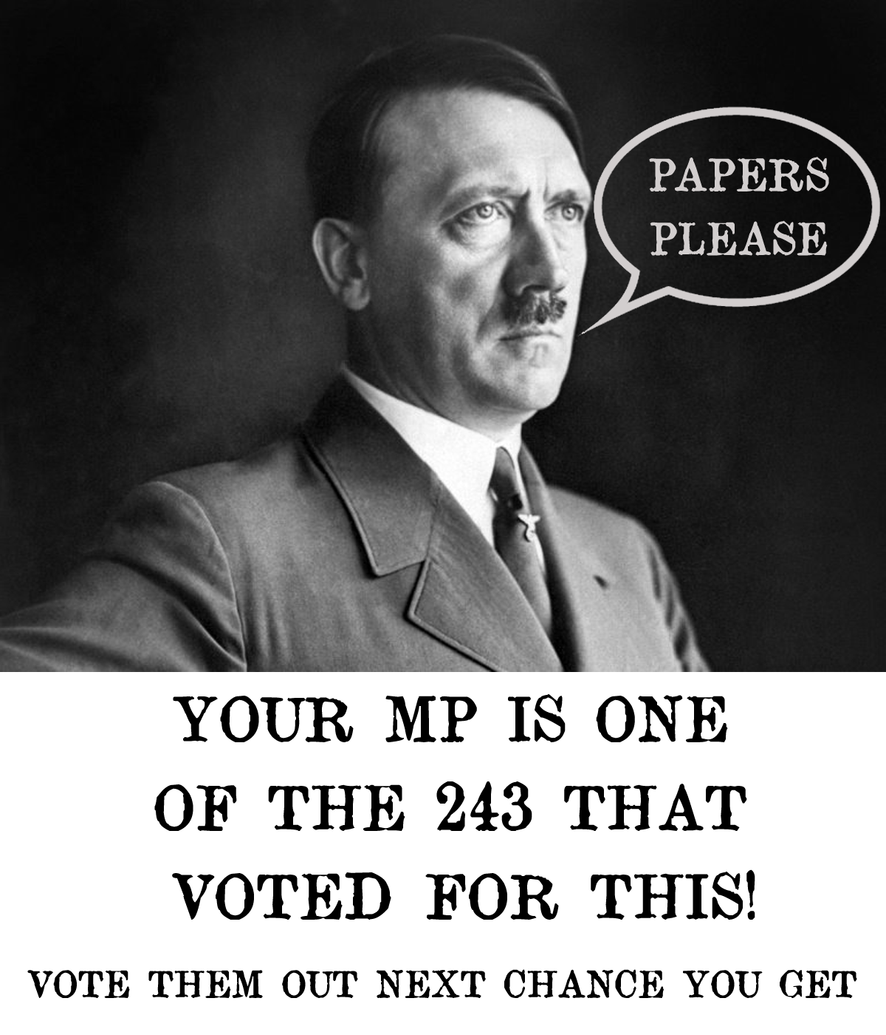
If your MP is one of the 243 that voted for "show me your papers" then this image needs to be displayed in and around their constituency, outside their constituency office, home and area they live!

